|  |  |
| --- | --- |
|  | **DEPARTMENT OF FIRST YEAR ENGINEERING** |

**Experiment No. 19**

|  |  |
| --- | --- |
| Semester | F.E. Semester II – First Year Engineering |
| Subject | C Programming (FEL204) |
| Subject Professor In-charge | Prof. Sanjeev Dwivedi Sir |
| Assisting Teachers | Prof. Sneha Annappanavar |

|  |  |
| --- | --- |
| Student Name | Deep Salunkhe |
| Roll Number | 21102A0014 |

**Title:**

**Program Code:**

**1)Call by Value**

#include<stdio.h>

#include<conio.h>

void swap(int x, int y)

{

 int temp;

 temp=x;

 x=y;

 y=temp;

}

int main()

{

 int x=10, y=20;

 swap(x, y);   // passing value to function

 printf("The Value of x:%d\n",x);

 printf("The Value of y:%d\n",y);

 getch();

 return 0;

}

**2)Call by reference**

#include<stdio.h>

#include<conio.h>

void swap(int *x, int *y)

{

 int temp;

 temp=*x;

 *x=*y;

 *y=temp;

}

int main()

{

 int x=10, y=20,a,b;

 swap(&a, &b);  // passing value to function

 printf("The Value of x:%d\n",x);

 printf("The Value of y:%d\n",y);

 getch();

 return 0;

}

**Output:**

**1)Call by Value**

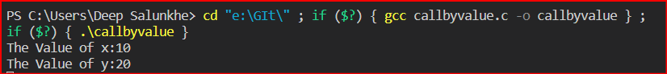

**2)Call by reference**

